1.Transfering the data from excel source to flat file destination

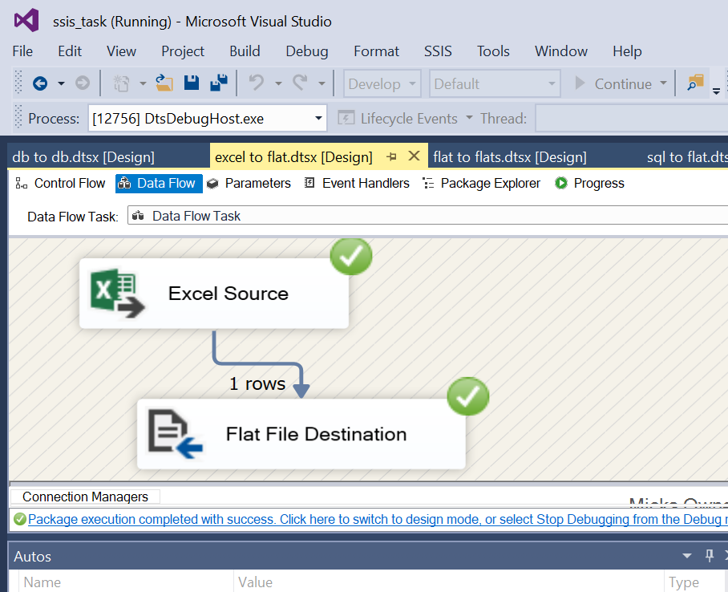

Source file

destination file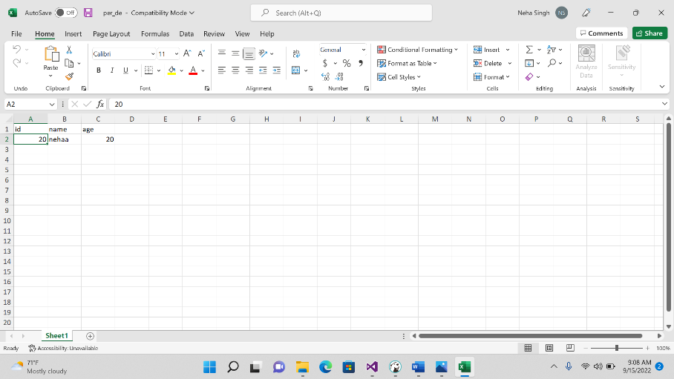

2.transfering the data from flat file source to excel file destination

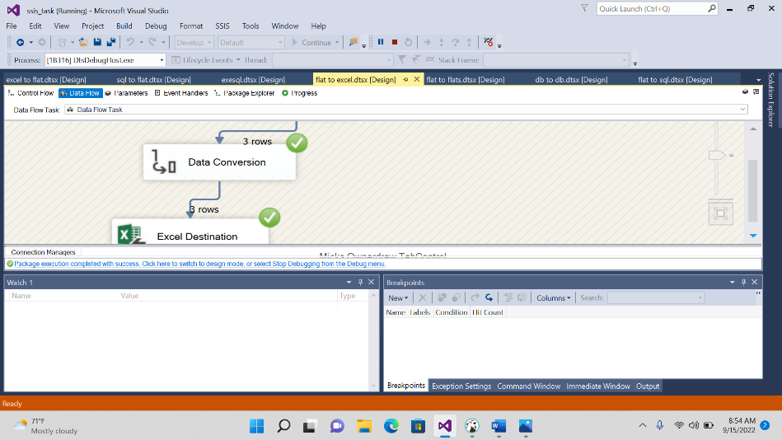

Source file

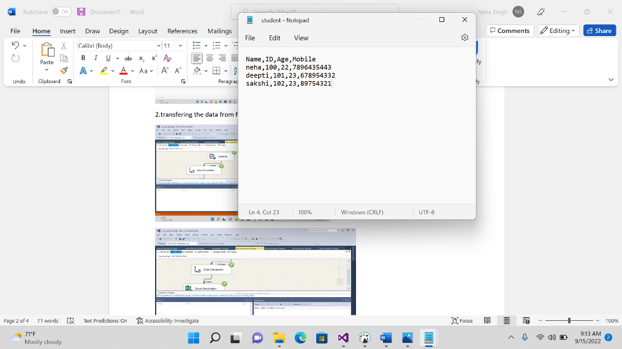

3.Transfer the data from flat source file to flat destination file

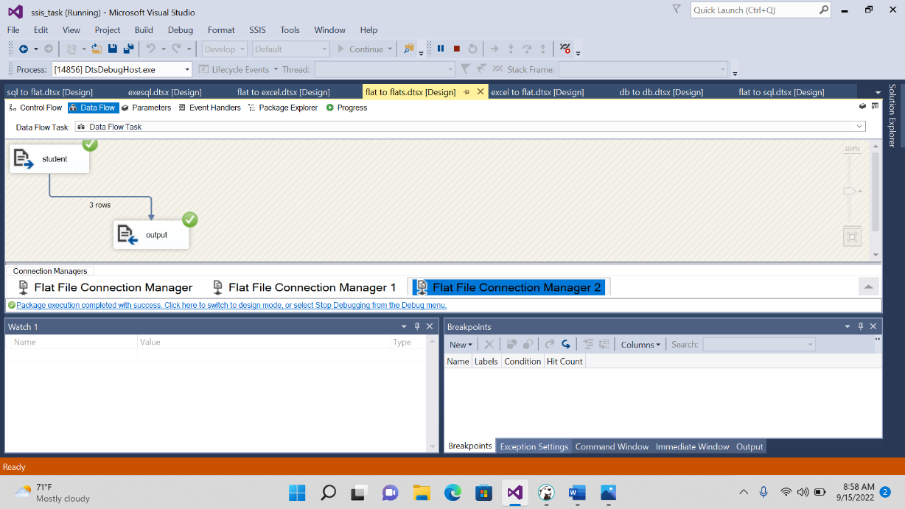

Source file

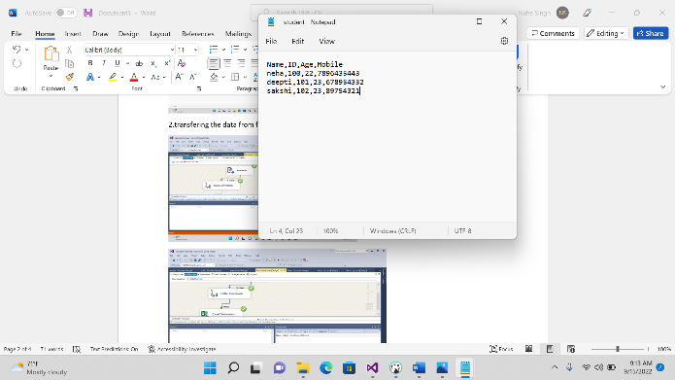

Destination file

4.Transfer the data from FLAT SOURCE FILE TO SQL DESTINATION FILE

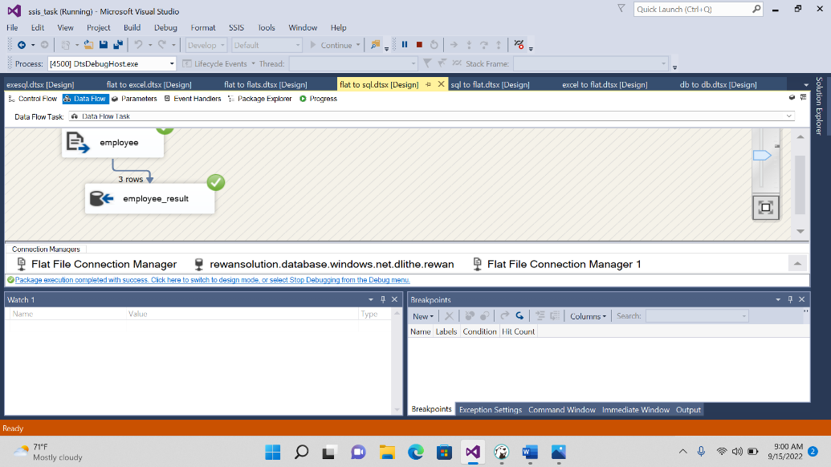

Source file

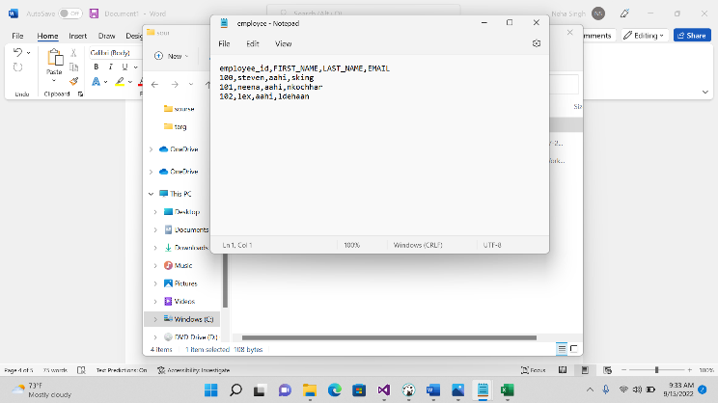

5.Transfering the data from sql source file to sql destination file

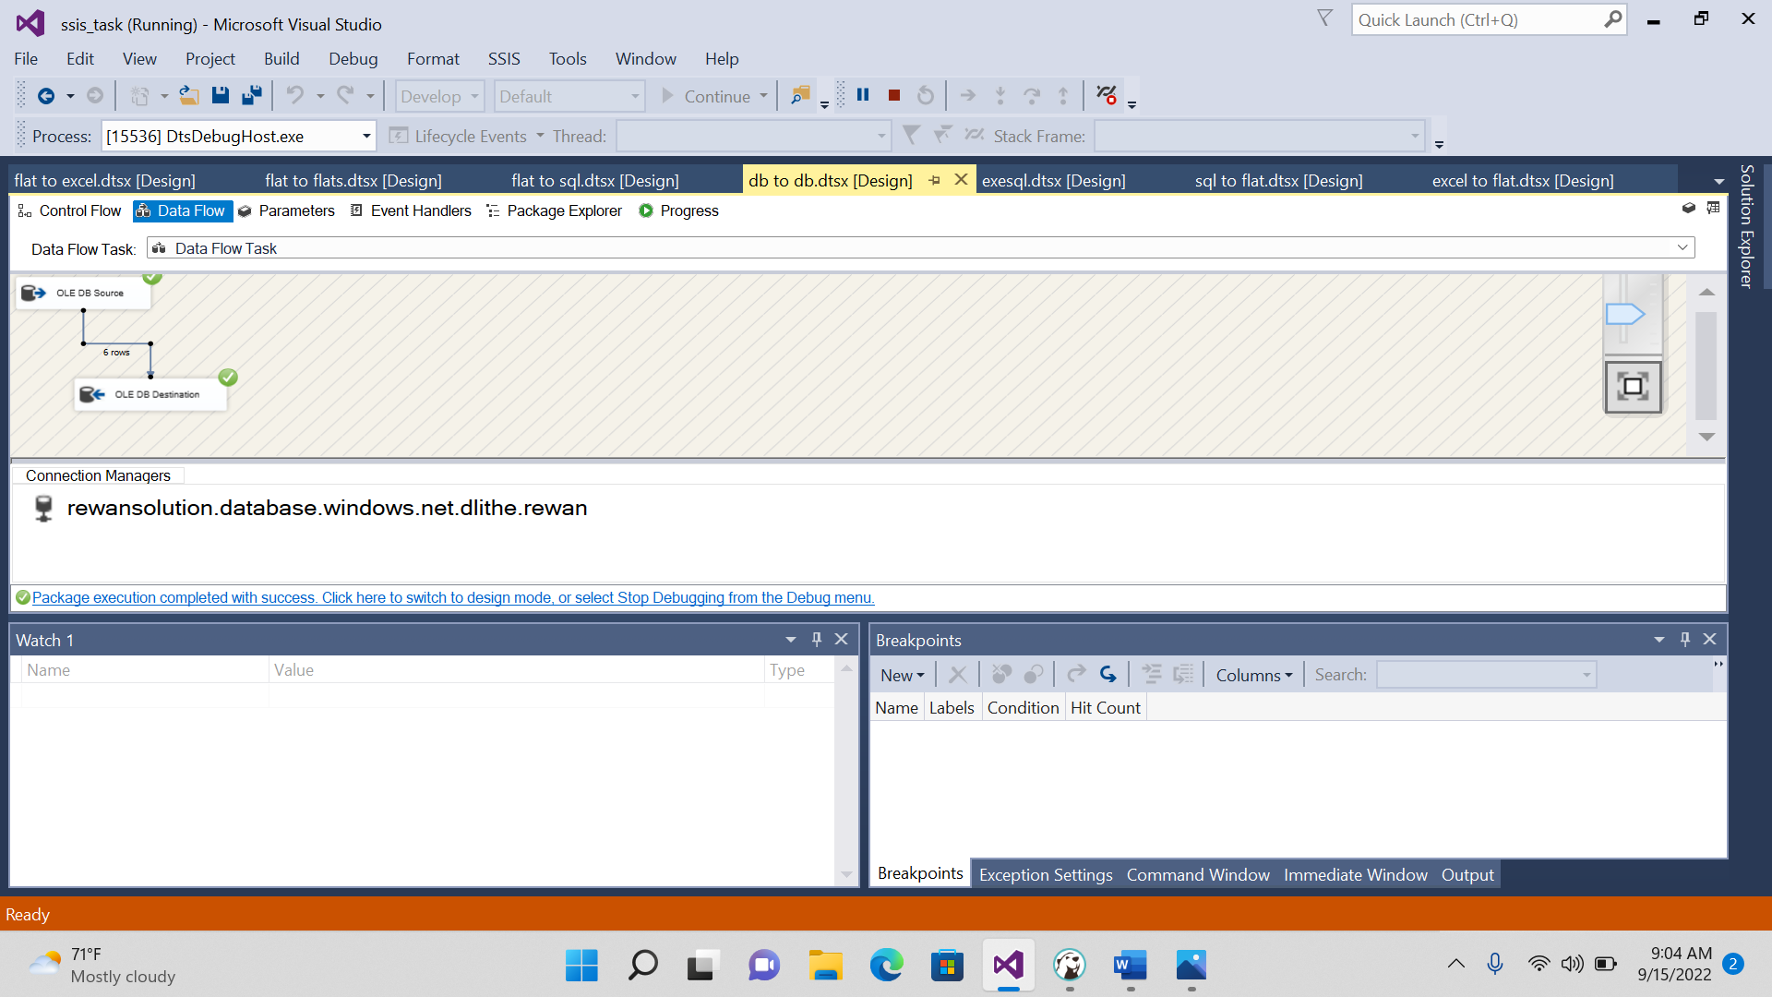

Source file queries

**create** **table** NA_student2(

s_name **varchar**(20),

s_id **int**,

s_age **int**,

s_mobile **int**

);

**insert** **into** NA_student2 **values**('neha',100,22,67896543)

**insert** **into** NA_student2 **values**('lavanya',101,23,8767811)

**insert** **into** NA_student2 **values**('shraeddha',102,22,7641200)

**select**\* **from** NA_student2

destination where we want data should be transfer from source to destination

**create** **table** NA_studentN1(

s_name **varchar**(20),

s_id **int**,

s_age **int**,

s_mobile **int**

);

**select** * **from** NA_studentN1

6.Transfering the data from sql source file to flat destination file

Source

**select** * **from** S_HREMPLOYEES sh

destination result

